L.N. Gumilev Eurasian National University

Faculty of Information Technologies

"Information systems" department

**REPORT**

**«Object Oriented Programming»**

Performed by: Bekenova A.B.

Group: IS-23

Verified by: Zhukabaeva T.K.

**Astana, 2024**

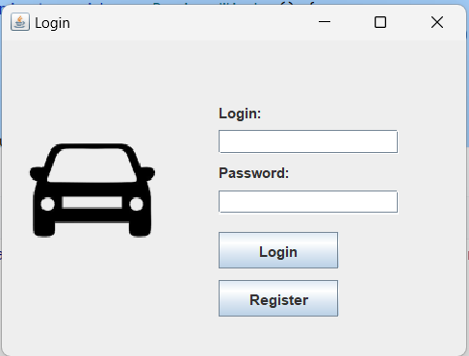

Fig 1 login or registration window

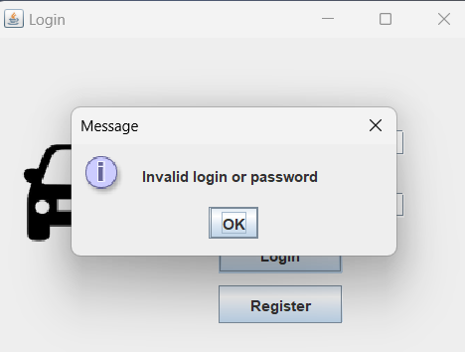

Fig 2 input data error message

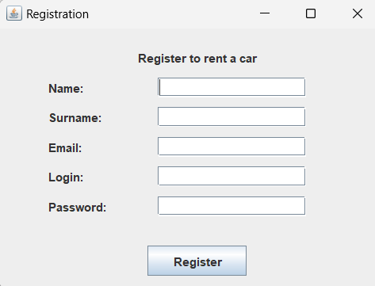

Fig 3 registration window

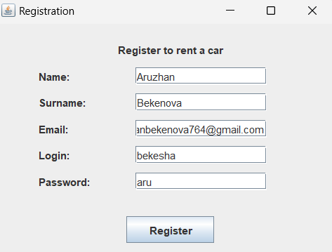

Fig 4 registration data entry

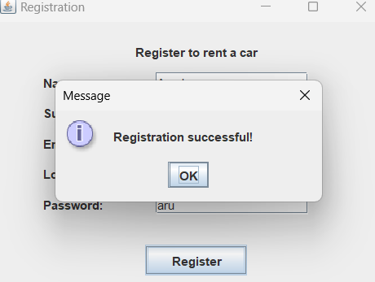

Fig 5 successful registration message

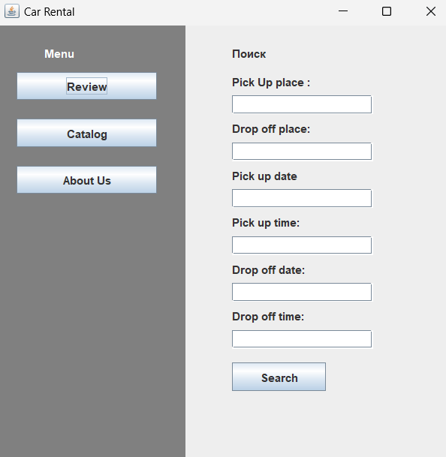

Fig 6 car reservation window and menu

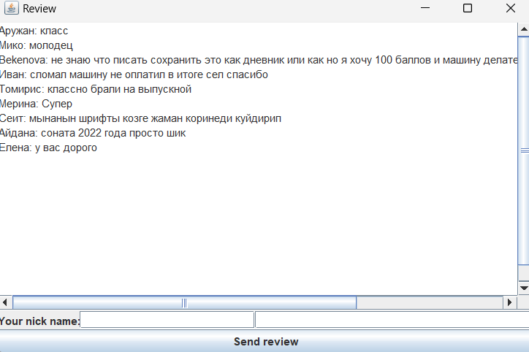

Fig 7 feedback window

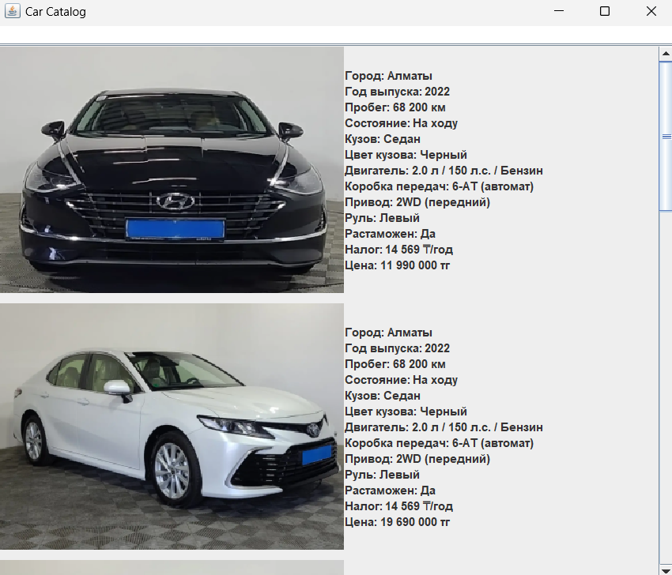

Fig 8 window for searching for machines in the catalog

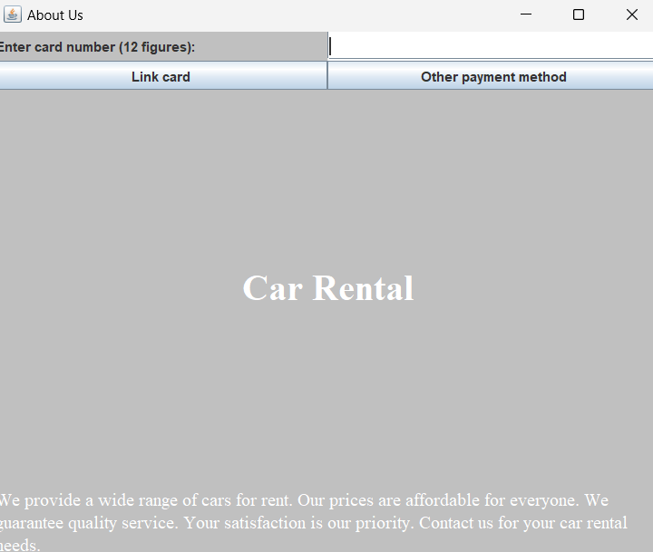

Fig 9 information window

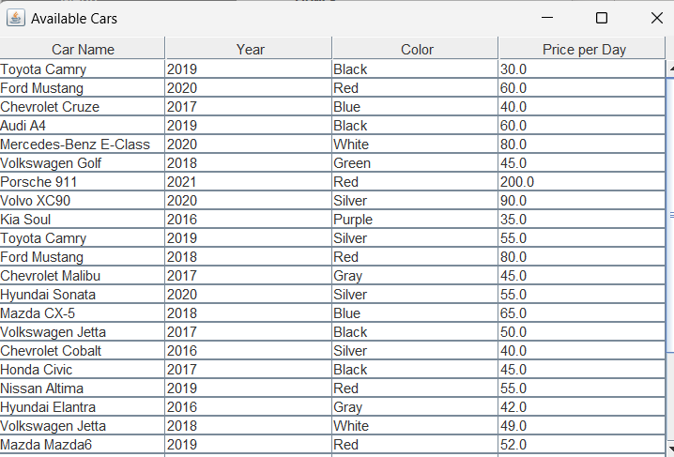

Fig 10 view available search cars

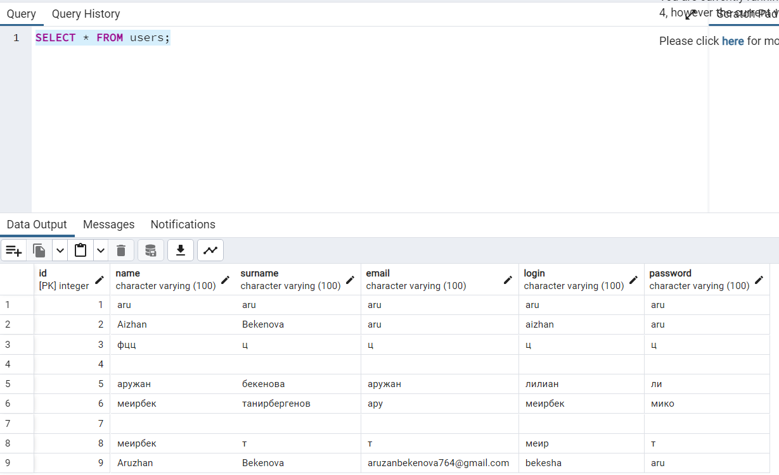

Fig 11 table for viewing registered users

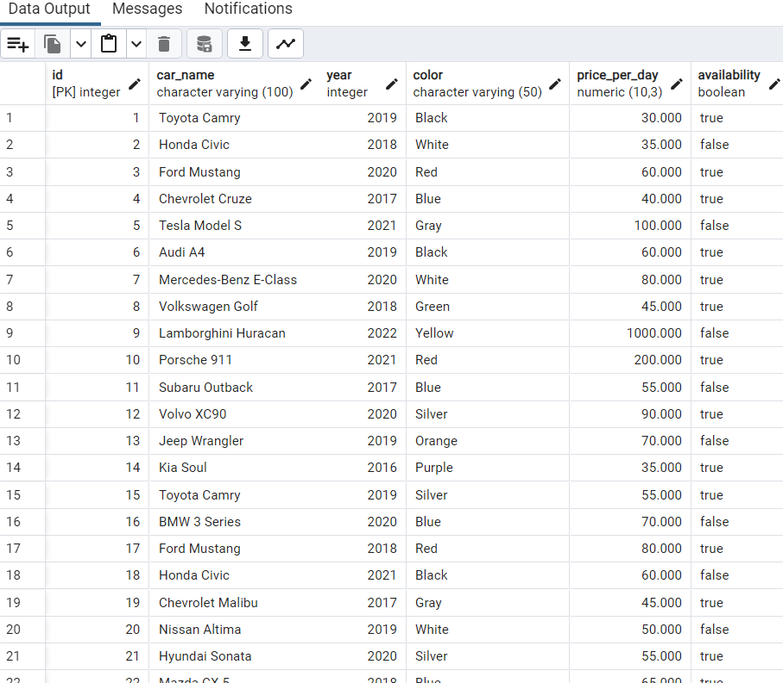

Fig 12 created database to view available cars

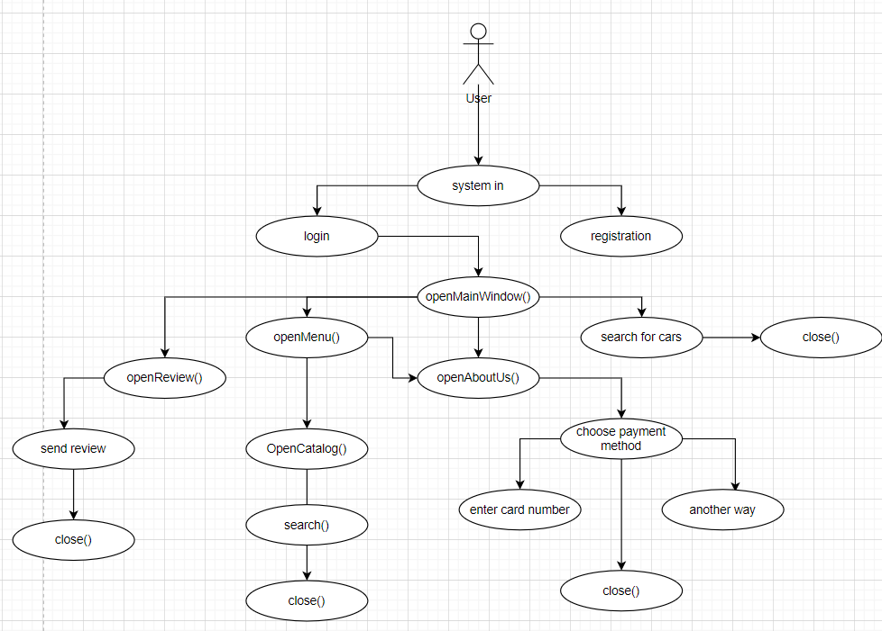

Fig 13 Flow chart diagram

Fig 14 Jira